RESUME

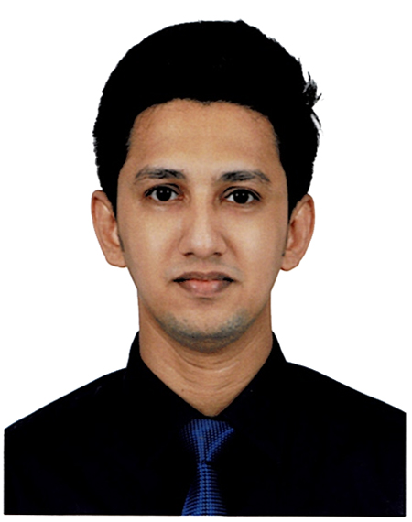

KAZI MOHAMMED SHAHRAN FORHAD

Mailing Address:
Kazi Bhaban, House No-29,
Block-B, Rahman Nager R/A, P.O- P.T.I,
P.S- Panchlaish, Chattogram.
Cell: +8801819632853
Mail: kazi_dinu@yahoo.com

CAREER OBJECTIVE:
To obtain a suitable job position in a reputed organization where nice working environment and decision making opportunities will enable me to contribute my best afford for the organization and attaining higher career building opportunities may be assured.

WORKING EXPERIENCE:
Officer (HR & Compliance)
Company Name : Univogue Garment Company Ltd.
Address : Sec-5, CEPZ, Chattogram.
Service Year : 1st February 2018 to Continuing

Executive

(Training & Development )
Company Name : Genex Infosys Ltd.
Address : BGMEA Bhaban, 669/E, Khulshi, Chattogram.
Service Year : 6th April 2017 to 31st January 2018

Executive (Marketing)
Company Name : CamTech
Address : 1st Floor, 601, Sk. Mujib Road, Agrabad, Chattogram.
Service Year : 1st March 2014 to 31st March 2017

ACADEMIC QUALIFICATION:

Masters of Business Administration (MBA)
Semester : 2.82
Major Subject : Human Resource Management
Year of Passing : 2017
University : Premier University Chittagong

Bachelor of Business Administration (BBA)
Result : CGPA 2.90 (Out of 4.00)
Major Subject : Human Resource Management
Year of Passing : 2016
University : Premier University Chittagong

Higher Secondary Certificate (HSC)
Result : CGPA 2.40 (Out of 5.00)
Year of Passing : 2010
Group : Business Studies
Name of the Institution : Al-Hajj Mustafa Hakim College Chittagong.
Name of the Board : Chattogram

Secondary School Certificate (SSC)
Result : CGPA 3.69 (Out of 5.00)
Year of Passing : 2008
Group : Business Studies
Name of the Institution : Garib-E-Newaz High School Chittagong.
Name of the Board : Chattogram

Potential Skill:
- Able to learn quickly.
- Able to make friendship easily.
- Able to disseminate knowledge with others.
- Able to work under pressure & like to face challenges.
- Able to create well working environment inside the organization.

Computer Skill:
Familiar and comfortable with the use of Windows Operating System (98, XP, Windows 7, 8, Vista), Microsoft Office, Using, basic knowledge about Computer Hardware, basic knowledge on internet usage.

Personal Information:
Father’s Name : Kazi Md. Hashim
Mother’s Name : Dil Afroz Begum
Date of Birth : May 10, 1992
Present Address : Kazi Bhaban, House No-29,
Block-B, Rahman Nager R/A, P.O- P.T.I,
P.S- Panchlaish, Chattogram.
Permanent Address : Do
Home District : Chattogram
Religion : Islam
Nationality : Bangladeshi by Birth
Sex : Male
Marital Status : Married
Height : 5’ 7’’
Area of Interest : Browsing on Net, Traveling & Listening Music

REFERENCE:
1. Md. Habib Yousuf Pearu
Proprietor
CamTech (Office Solution Propritor)
Director
Systex Fashion Ltd.
1st Floor, 601, Sk. Mujib Road, Agrabad, Chattogram.
Cell: 01554 315 751, 01716 085 069
E-mail: hbyousuf@gmail.com

2. Mr. Md. Foisal Uddin
Director (Admin & Finance)
Fusion Foods Ltd.
Rahman Bhaban, 23/24, P.C Road, Nimtala,
Bandar, Chattogram (4100)
Contact No: 01847-188702
Email: foisal.fusiongroup@yahoo.com

Declaration
I hereby declare that all the details mentioned above are my own and true to the best of my knowledge.


(Kazi Mohammed Shahran Forhad)

